**ASSIGNMENT -2 (DSA01 C++ PROGRAMMING)**

**NAME:K Vishnu Vardhan**

**REG.NO: 192110362**

**QUESTION 1:**

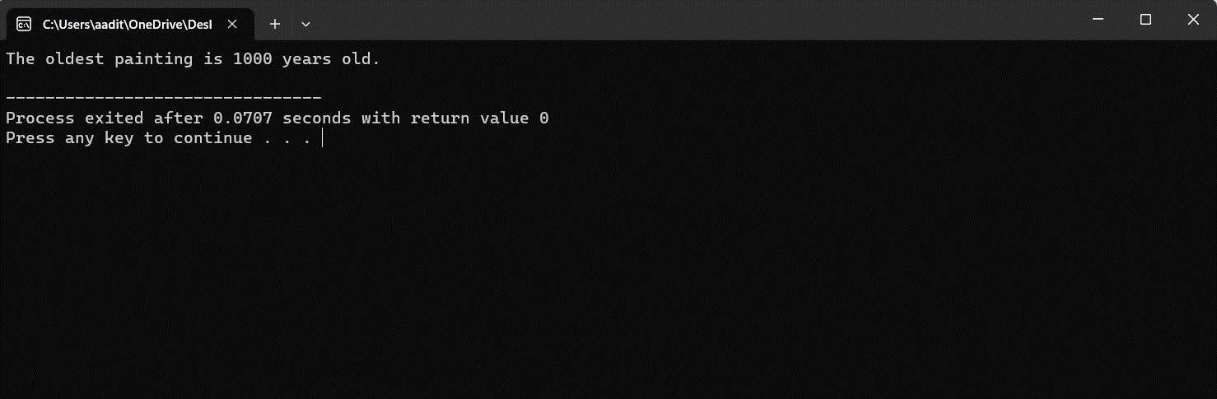

**QUESTION 2:**

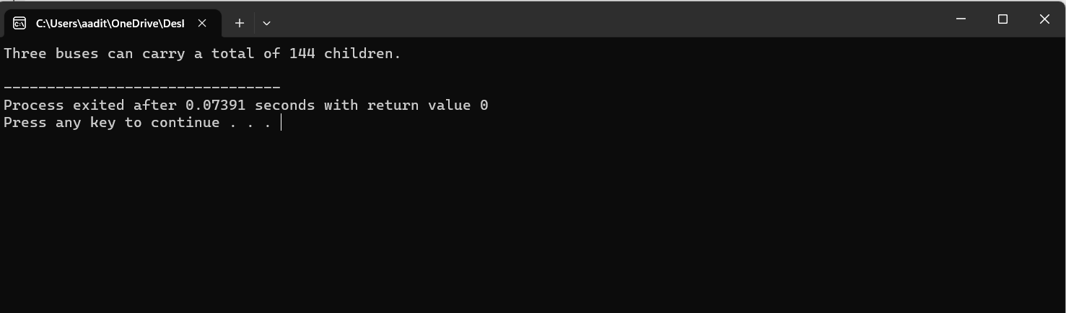

**QUESTION 3:**

